**ACE/APP Data Meeting Report Updated: 01/29/2021**

**Agenda**

1. User log usage report
2. APP/BRAIN/GAIN Data Update
   1. HPT data modified
3. STAAR Data Update
   1. Data processing (attachment available)
4. Questions / Concerns

**User Log Report**

* 0 bug report in December and January
* Average time of using the data portal is 7.5 mins.
* 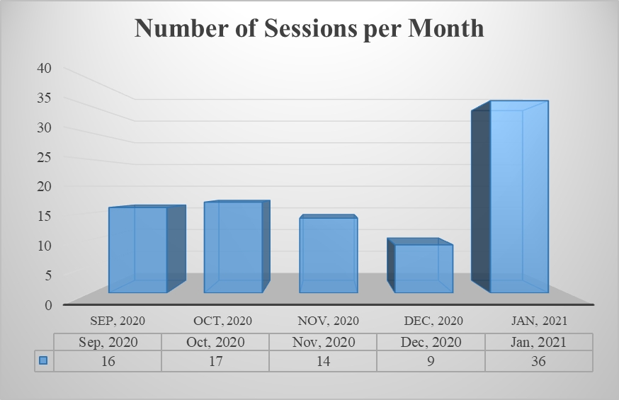The results by months are shown below: